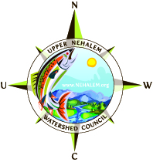
OWEB Project #210-1009
Elk Creek Phase II – Fish Passage Restoration
Final Report

March 2011

(1) A brief, narrative description of the project including:
- Background on the problem that generated the project;

Project Location:
Elk Creek is a tributary to the East Fork Nehalem River in Columbia County located in the northern coast range of Oregon. Elk creek has a watershed size of approximately 3 square miles and flows into the E F Nehalem at river mile 4.4, and the EF Nehalem enters the Nehalem River Mainstem at RM 84, approximately 5 miles northeast of the town of Vernonia. The primary land use within the EF Nehalem and Elk creek watersheds is industrial timberland. 68% of the EF watershed is owned by private industrial wood product companies, 22% is administered by the Bureau of Land Management (BLM), with the remaining 10% of land being owned by private individuals, many of them managing their land for timber production. The geology consists of shallow, highly erodible silt loam soils overlaying sedimentary sandstone. On steeper slopes these soils are prone to mass wasting and, where disturbance has occurred, surface erosion. Elk creek was once known (Dale Webb, 96) to produce a healthy run of Coho salmon before a blockage occurred near the mouth at the Mckee mainline crossing.

Site condition prior to project implementation:
Sometime in the 1950’s the original bridge at the Elk Creek Scappoose Vernonia Hwy crossing was replaced with a concrete box culvert, installed by the Columbia County Road Department. The culvert was 60ft long and 96in diameter, with a 12 inch low-flow perch at the outlet. The bottom of the culvert was 100% bare concrete. Outflow pool depth is 24 inches. Culvert slope was 2%, with 0-1% stream slopes beyond both the inflow and the outflow. Adult salmon passage was inhibited by high velocities during winter flows and lack of bottom roughness, but it was not considered a barrier to adults. Juvenile passage was blocked year-round due to summer perch height, lack of bottom roughness and winter velocities. Ever rising in-stream temperatures, at the end of July – early August in the mainstream Nehalem, above and below the confluence of the East Fork Nehalem and in mainstream East Fork from the mouth upstream beyond the confluence of Elk Creek (UNWC, NVC IWL, BLM), makes juvenile access to cool water refuge in Elk Creek imperative for juvenile Coho survival.

A previous OWEB Technical Assistance grant (206-003) was used to develop engineering designs and cost estimates for this site. USFWS funds were used to suppliment the design project.

- A description of the work done, placing it in its larger watershed context;
This project allowed UNWC to work with Columbia County Road Department to restore fish passage at the Scappoose-Vernonia County Road at the Elk Creek crossing. Other funding partners included USFWS – Partners for Wildlife ($29,981,64), and the National Fish and Wildlife Foundation – Governor’s Fund for the Environment ($50,000.00) to replace an undersized concrete box culvert on the Scappoose-Vernonia County Road that is a known juvenile salmon passage barrier (ODFW, Boswell 05, Bio-Survey’s 08-10). The replacement crossing is pre-cast concrete sections (21), 24 ft. wide by 12 ft. high (6 ft. clearance with added cobble substrate) 100 ft. long open-bottom D-frame Crownspan.

This project implemented Phase II of a collective effort to restore fish passage to 3.6 miles of essential salmon habitat in Elk creek (Phase I McKee crossing 600 ft. upstream). This project is part of a larger watershed wide restoration effort focused within the East Fork Nehalem by the Upper Nehalem Watershed Council (UNWC) and its partners (Weyerhauser Corporation, Columbia County, ODFW, BLM and USFWS). Elk creek was chosen as the first project undertaken to address fish passage under the new EF Nehalem – action plan (UNWC/Demeter Design, 08).

- A description and explanation of any changes to the original proposal;

The project was implemented according to the Lower Columbia Engineering salmon passage design with one adjustment being made to avoid encroachment out of the right-of-way to downstream landowner. One budget amendment was approved by OWEB on 8-8-10 to shift $175,000 from Contracted Services into Supplies/Materials to allow UNWC to purchase the Hanson C-Span crossing components separate from the construction contract with Columbia County/TFT. By doing this it enabled UNWC to have Hanson pour the 21 concrete C-Span sections, while Col. Co. Rd Dept. completed their search for and negotiations with a construction contractor, so the sections would be cured in time to install during the summer of 2010 in-stream work window. As it turned out an extension to the in-stream work window had to be authorized by ODFW to allow the project to be completed due to other delays that occurred during the actual construction.

- A summary of any public awareness or educational activities related to the project, including identification of any tours or presentations and copies of newspaper or other media coverage about the project;

The Vernonia Voice newspaper did an article highlighting restoration efforts in the East Fork Nehalem that included the Elk Creek S/V project (see attached). The Vernonia Voice is in the process of doing a follow-up story now (will appear in paper later in March). UNWC conducted two project tours since the project was completed, one with the UNWC interim steering committee, and one with the OWEB Technical Advisory Team. Both groups seemed to be satisfied with the project results.

- Lessons learned, if any, from the project; and
- Recommendations, if any, for more effective implementation of similar projects.

Easement: project implementation became stalled in the eleventh hour while Columbia County attempted to negotiate a temporary easement from the effected downstream landowner. The landowner was resistant to allowing an easement onto their land during construction and waited until very late in the discussion to ask for compensation. No funding had been set aside to pay for the easement and it was then determined that the project would be constructed with-out the easement in such a way as to avoid impact to downstream landowner. The extended negotiation stalled other aspects of the project moving forward and compressed the implementation window causing unneeded stress to all concerned. Recommendation: in the future we will be sure to identify right-of-way and easement issues earlier in the process in order to avoid untimely delays.

Project Management: some confusion occurred during the project construction as to expectations of roles and responsibilities between County engineer and Lower Columbia Engineering and UNWC project manager and ODFW – restoration biologist. Due to the cooperative nature of each member of the team the issues were quickly identified and remedied resulting in no lasting negative impact to the project.
Recommendation: in the future we have each agreed to collectively spend more time in the initial planning stages defining and comparing our roles and responsibilities before we move into implementation.

Salmon Passage: at the time the project was completed the contractor had placed all the stream cobble in such a way as there remained no defined thalweg and leaving Elk Creek flowing sub-surface. This reality raised concerns with ODFW and USFWS project partner reps that adult salmon would not have passage during the first spawning season. Although these concerns were valid, and should have been addressed by the contractor during construction, it was determined that once the first heavy rains occurred that the high flows would flush sediment through, shift and settle the loose cobble, define a high flow channel, bring the flows above the substrate and allow Coho passage the first spawning season. This in fact did occur and Coho passed through the restored stream reach unimpeded.
Recommendation: make it crystal clear with the contractor in the construction contract and again prior to construction the salmon passage expectation at the completion of the project.

In-stream work period: the contractor pushed the limits of the in-stream work period into an ODFW extension and beyond… with the project in full swing and the fall rainy season fast approaching… this was simply nerve racking to those concerned.
Recommendation: make it crystal clear with the contractor in the construction contract and again prior to construction that the in-stream work period must be adhered to and that a daily penalty will be charged for pushing the project beyond the in-stream work period.

(2) Documentation that the project complies with the Oregon Aquatic Habitat Restoration and Enhancement Guide, if applicable.

The new C-Span open bottom arch structure, as constructed, does not have the potential to hinder or block the free movement of native salmon, juveniles and adults, up - or downstream there-fore bringing it into compliance with state law (ORS 498.351 and 509.605). A sound technical design for fish passage was developed by Lower Columbia Engineering, approved by Michele Long – ODFW Aquatic Restoration Biologist and permitted by the Oregon Department of State Lands under General authorization permit #: 44568-GA.

(3) Color photographs of the project areas before and after the project completion take at pre-set photo points.

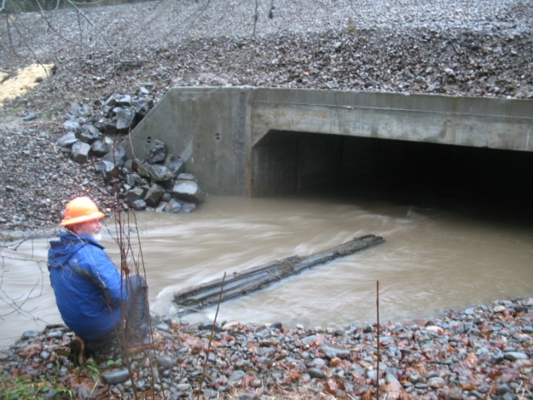
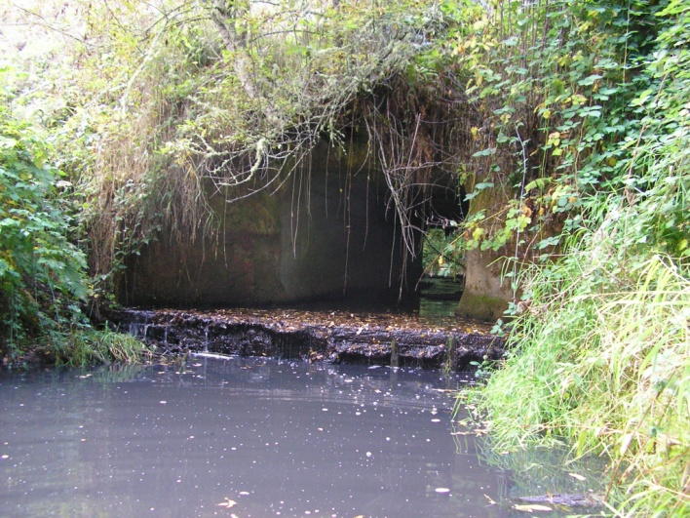
Before… After…

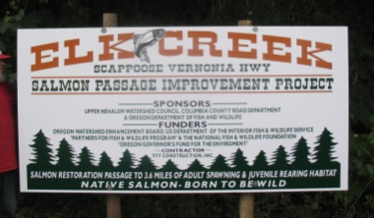

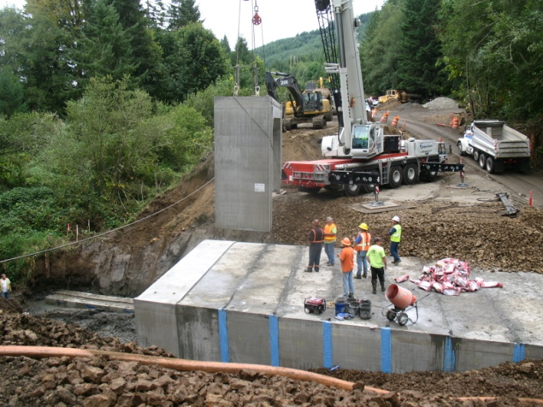
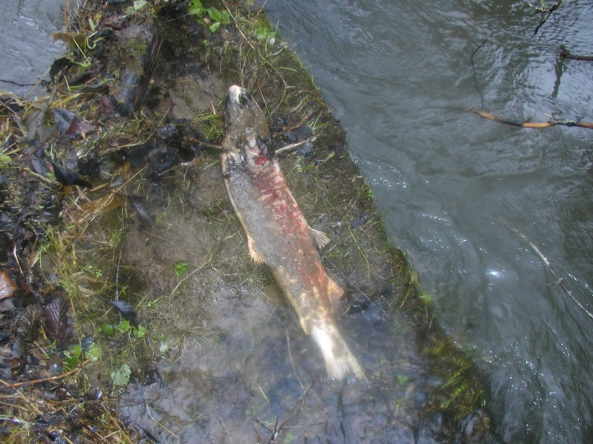
During…

Spawned out Coho salmon – above new crossing

(4) Completed copy of the most current version of the Oregon Watershed Restoration Inventory (OWRI) with the required map(s) and location information.

See attached: aerial/topo maps. OWRI form completed/submitted in the new web based interface.

(5) An accounting of the expenditures of Board moneys and all other funding in the project, including a final accounting of all in-kind contributions, donations and the required non-Board match funds.

See attached.

